Service Procedure

Dear partners,

We would like to inform you that in case that you have incidents from a client or when you receive products at the store like:
- Damaged packaging in delivery
- Damage Product Inside
- DOA (Dead On Arrival)
- Not working Properly

The time to report it is the following:

- Damaged packaging in delivery – When the store receives the product.
- Damage Product Inside – Until 5 Working Days since the purchase
- DOA (Dead On Arrival) – Until 7 Working Days since the purchase
- Not working Properly – According to Guarantee

In order to request the replacement of the product, you need to do the following procedure:

- The store agent confirms:
  - The Bon Fiscal for the purchase of the Product.
  - That the product has all its spare parts in the box (charger – cables etc)

- The store sends to GlodalSat an email with the following information:
- Photo of the product
- A filled in Service Report Document with the:
  - Date of receiving the Product (from client of Orbit)
  - Vodafone Store Code
  - Item Vodafone Code
  - Item Description
  - A quick description of the problem

- Number of pieces (in case they are more)

The AVIZ number will be filled in Manually after the approval.

- In the subject of the email, the store will write:
- the shop code.
- Vodafone Code (s)
- Reason ex.:
  - Request for Replacement of AGS0000029 with Defective Packaging
  - Request for Return of AGS0000030 - DOA

In case they are more than one products then the Vodafone codes will be written in the body of the email

The store will send the email to: shopsupport@globalsat.ro

Example of email

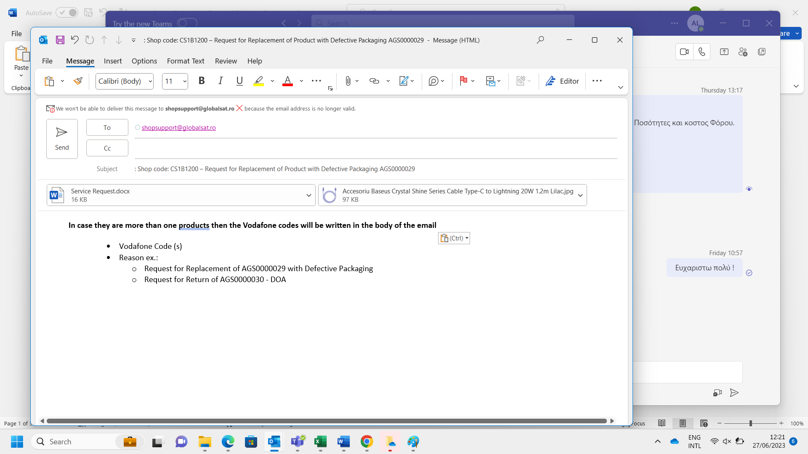

As soon as we have processed all the above information, we will inform by email for the next steps of all the item requests status:

- Approval to return the product by sending also the Return Order for Replacement,

In this case the store prepares the AVIZ which has:
- AVIZ Number
  - On the AVIZ must be mentioned:
    - Item Code Vodafone
    - Item Description
    - Barcode or Serial Number – if there also the packaging of the item
The AVIZ will be issued to Globalsat Fiscal Data with delivery to Orbit Address of the Warehouse

The store must glue out of the box a copy of the Return Order which practically will write what is inside in the box to be collected from Orbit.

  - In the meantime, the store can replace the product to the client with a new one.
  - Globalsat will replace this product to the store.

- Pending – In case we need to wait for the approval of the supplier ex. Apple.
  - In this case the store will be informed as soon as we have info of the next steps
  - From here the status will be changed to:
    - Approved – This means that we follow the steps above.
    - Not Approved – In this case no further actions will be made.

- Not Approved – In case ex. Not all spare parts were returned to the store.

Comments:

- The store must always inform the client that the Bon Fiscal or Invoice is also the way to claim the guaranty in case of any incident.

- All products have 24 months of Guarantee except the categories below that they do have any Guarantee.
  - Armbands
  - Belt Cases
  - Cases
  - Consumable Batteries (AA, AAA, etc.)
  - Screen Protector
  - Sport Belt
  - Tempered Glass

- As long as the return is made correctly, the store will be credited for its value.
- In case that no damage is found during the technical inspection, then the store will be re-invoiced.
- The end customer will be given the same product without the packaging if it is active code or its substitute at the same value.

- In case the store needs to send a product for service, the procedure that they need to follow is the same.

GS Support

Globalsat S.A.

